Warehouse Management (WM)
Case Study II
This case study explains an integrated warehouse management process which is triggered by a stock transport order from a manufacturing facility to a warehouse-managed storage location.

Product  SAP ERP  G.B.I.  Release 6.07  Level  Beginner  Focus  Warehouse Management  Authors  Simha Magal  Stefan Weidner  Chris Bernhardt  Version  2.40  Last Update  June 2015 | MOTIVATION  Warehousing has significant value for logistics.  Current trends such as higher cost pressure, shorter cycles of innovation, higher customer expectations and globalization of markets make great demands on companies, in particular on warehouse logistics. This is especially difficult in industries with high differentiation like the consumer goods industry. Furthermore, customers have increasingly higher demands on reliability, promptness and flexibility of deliveries.  Warehouse management systems support the global flow of goods between the producer and the purchaser and facilitate near fail-proof logistic operations in increasingly complex supply chains. |  | PREREQUISITES  Before you use this case study, you should be familiar with navigation in the SAP system.  In order to successfully work through this case study, it is not necessary to have finished the WM exercises. However, it is recommended.  NOTES  This case study uses the Global Bike Inc. (G.B.I.) data set, which has exclusively been created for SAP UA global curricula.



 | Process Overview
Learning Objective Understand and perform a warehousing process for int. goods Time 90 min
Scenario Due to increasing sales output in your San Diego distribution center, the management has decided to install a Warehouse Management System there. These adjustments have just been completed. Now the new system needs to be tested. For this purpose, finished goods shall be requested from your manufacturing facility in Dallas and put in stock in San Diego using the new warehouse management system.
Employees involved Carolin Bruzik (Warehouse Supervisor)
Jennifer Brown (Plant Manager San Diego)
Sanjay Datar (Warehouse Employee)
Yoshi Agawa (Receiving Clerk)
In order to receive goods from the plant in Dallas you need to create a stock transport order. Then you will send goods from the plant to the distribution center. As soon as you register the receipt of the goods in San Diego, you will create a transfer order for the received goods. Due to this order, the Warehouse Management will put the goods into stock. In the end, you will check if the goods were sorted into the correct storage bins. |  | Process description
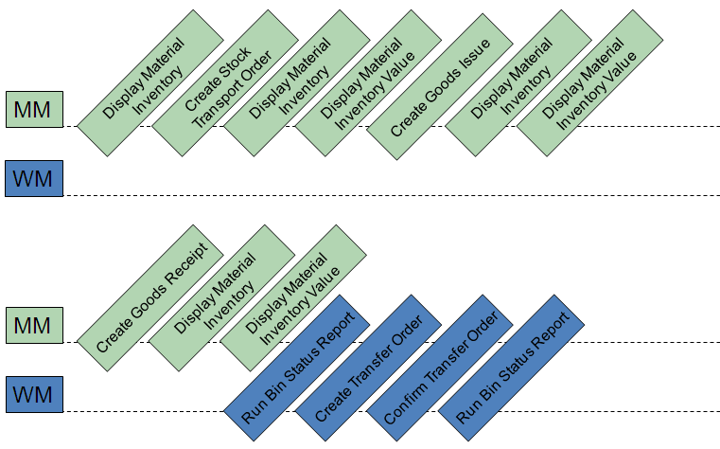

 | Step 1: Display Material Inventory
Task View the inventory of your material. Time 5 min
Short Description Use the Easy Access Menu to display the inventory of your material.
Name (Position) Carolin Bruzik (Warehouse Supervisor)
To display the material inventory, follow the menu path:  Logistics ► Materials Management ► Inventory Management ► Environment ► Stock ► Stock Overview |  | Menu path
In the Stock Overview screen, enter DXTR1### as Material (replace ### with your number). Make sure that all other search criteria fields are blank and click on . |  | DXTR1###
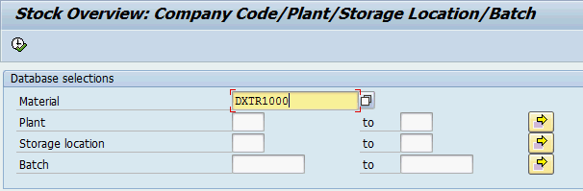
In the following screen you see the global amount of your material on stock as well as the current amount in your Dallas plant which you will order the material from.
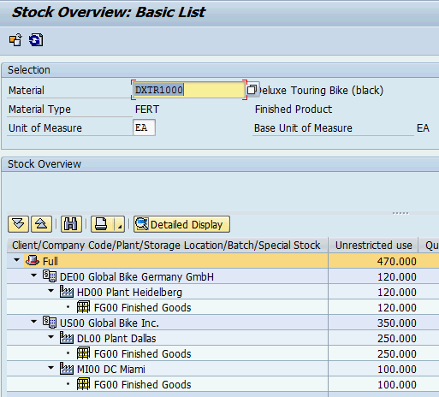
Click on the exit icon to return to the SAP Easy Access screen.

 | Step 2: Create Stock Transport Order
Task Create a stock transport order. Time 10 min
Short Description Use the Easy Access Menu to create a stock transport order. This means that you request material from another GBI plant instead of procuring it from a vendor.
Name (Position) Jennifer Brown (Plant Manager San Diego)
To create a stock transport order, follow the menu path:  Logistics ► Materials Management ► Purchasing ► Purchase Order ► Create ► Vendor / Supplying Plant Known |  | Menu path
In the Create Purchase Order screen, change the type of purchase order to Stock Transp. Order and accept any warning messages with Enter. Fill in US00 as Purch.Org., N00 as Purch. Group, US00 as Company Code and DL00 as Supplying Plant. |  | Stock Transp. Order  US00  N00  US00  DL00
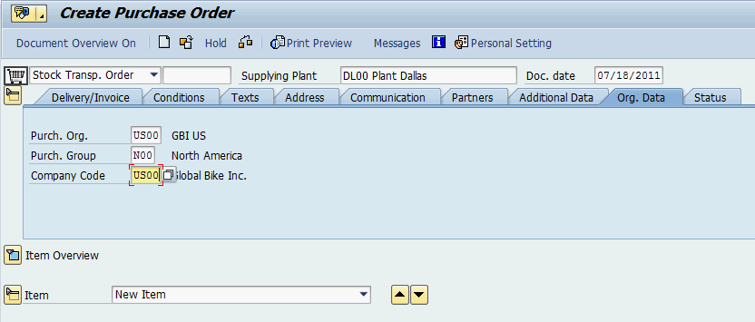
Select to expand the Item Overview. Enter DXTR1### as Material (replace ### with your number), 10 as PO Quantity, SD00 as Plant, FG00 as Storage Location and 8 days from today as Delivery Date. Confirm your entries by clicking or pressing Enter. |  | DXTR1###  10  SD00  FG00  8 days from today
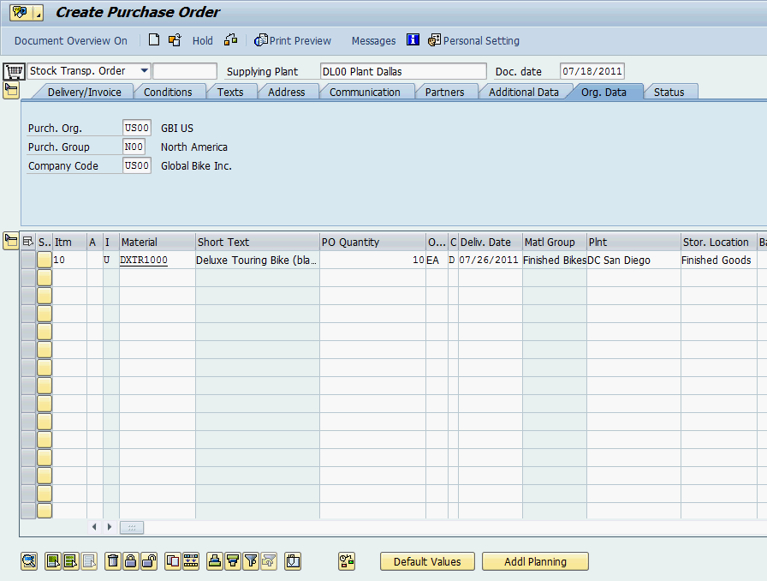
Compare your entries with the screenshot above.
Then, click on to save your order. You may receive a warning message which you can ignore by clicking on Save. The system will assign a unique stock transport order document number. |  | Stock Transport  Order Number
Click on the exit icon to return to the SAP Easy Access screen.

 | Step 3: Display Material Inventory
Task View the inventory of your material again. Time 5 min
Short Description Use the Easy Access Menu to display the inventory of your material again.
Name (Position) Carolin Bruzik (Warehouse Supervisor)
To display the material inventory, follow the menu path:  Logistics ► Materials Management ► Inventory Management ► Environment ► Stock ► Stock Overview |  | Menu path
In the Stock Overview screen, enter DXTR1### as Material (remember to replace ### with your number). Ensure that all other search criteria fields are blank and click on . |  | DXTR1###
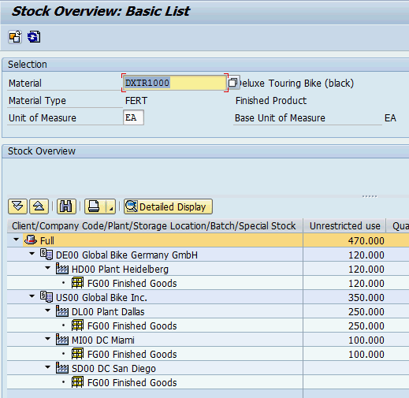
Note that you still have the same amount of goods in Dallas. However, after double clicking on SD00 DC San Diego you can see that you have an On-Order Stock balance of 10 for your distribution center in San Diego.
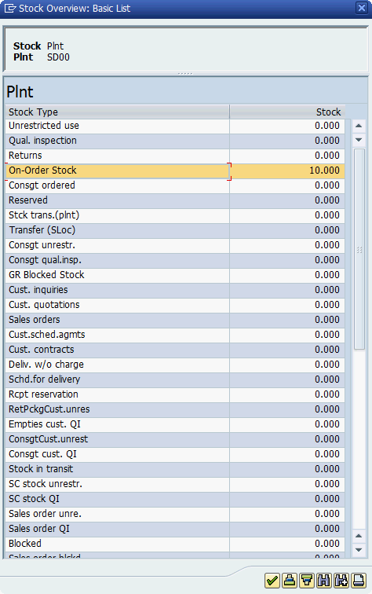
Click on the exit icon to return to the SAP Easy Access screen.

 | Step 4: Display Material Inventory Value
Task View the value of your material inventory. Time 5 min
Short Description Use the Easy Access Menu to display the value of your material inventory.
Name (Position) Carolin Bruzik (Warehouse Supervisor)
To display the material inventory value, follow the menu path:  Logistics ► Materials Management ► Inventory Management ► Environment ► Stock ► Warehouse Stock |  | Menu path
In the Display Warehouse Stocks of Material screen, enter DXTR1### as Material (replace ### with your number). Ensure that all other search criteria fields are blank and click on . |  | DXTR1###
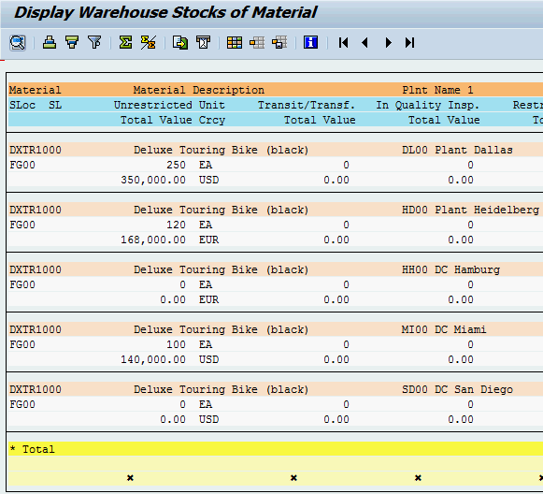
As you can see there is no total value associated with the DC in San Diego.
Click on the exit icon twice to return to the SAP Easy Access screen.

 | Step 5: Create Goods Issue
Task Create a goods issue from the issuing plant. Time 10 min
Short Description In this step, you will use the Easy Access Menu to issue the goods requested from your plant in Dallas to your distribution center in San Diego.
Name (Position) Sanjay Datar (Warehouse Employee)
To create a goods issue, follow the menu path:  Logistics ► Materials Management ► Inventory Management ► Goods Movement ► Goods Movement |  | Menu path
In the Goods Movement screen, change the Material Document drop down to Goods Issue and adjust the type of Goods Issue to a Purchase Order. |  | Goods Issue  Purchase Order
Note: A purchase order is the same as a stock transport order, you are technically purchasing the goods from the other plant, but it is a transport because the plants are under the same company code.
Input your Stock Transport Order Number in the blank space next to it. |  | Stock Transp. Order Nr.
If you have not written down the TO number you created in the second task, you may use the F4 help in the TO number field (first blank field next to the second drop-down field).
In the following screen choose the Purchasing Documents for Material tab by using . Then, enter DXTR1### as Material and press Enter. |  | DXTR1###
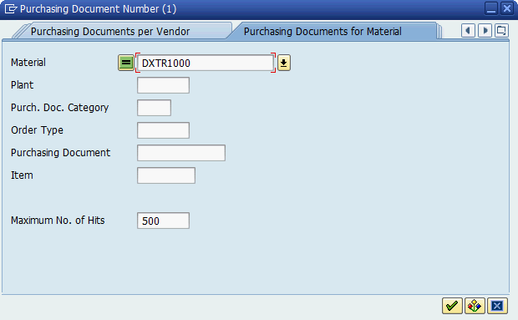
Now double click on your entry.
After your order number is filled in click on or press Enter.
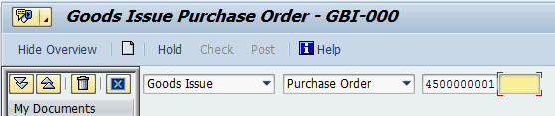
When your order comes up select OK and enter Finished Goods as Storage Location by using the F4 help. Confirm your entries by clicking or pressing Enter. |  | OK  Finished Goods
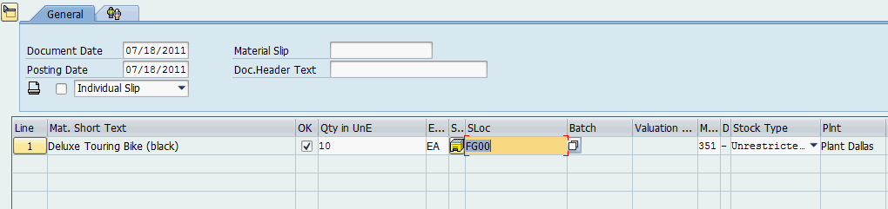
Then, click on to save your issue. The system will assign a unique material document number. |  | Material Document Number
Click on the exit icon to return to the SAP Easy Access screen.

 | Step 6: Display Material Inventory
Task View the inventory of your material again. Time 5 min
Short Description Use the Easy Access Menu to display the inventory of your material again.
Name (Position) Carolin Bruzik (Warehouse Supervisor)
To display the material inventory, follow the menu path:  Logistics ► Materials Management ► Inventory Management ► Environment ► Stock ► Stock Overview |  | Menu path
In the Stock Overview screen, enter DXTR1### as Material (remember to replace ### with your number). Ensure that all other search criteria fields are blank and click on . |  | DXTR1###
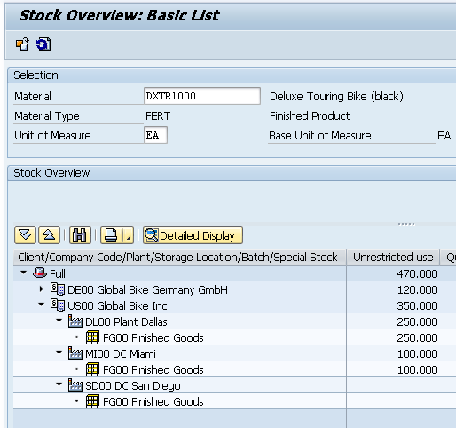
Note that your amount of goods in Dallas has changed now. By double clicking on SD00 DC San Diego you can also see, that you still have an On-Order Stock balance of 10 for your distribution center in San Diego. This means that the goods have not arrived in San Diego yet.
Click on the exit icon to return to the SAP Easy Access screen.

 | Step 7: Display Material Inventory Value
Task View the value of your material inventory again. Time 5 min
Short Description Use the Easy Access Menu to display the value of your material inventory again.
Name (Position) Carolin Bruzik (Warehouse Supervisor)
To display the material inventory value, follow the menu path:  Logistics ► Materials Management ► Inventory Management ► Environment ► Stock ► Warehouse Stock |  | Menu path
In the Display Warehouse Stocks of Material screen, enter DXTR1### as Material (remember to replace ### with your number). Ensure that all other search criteria fields are blank and click on . |  | DXTR1###
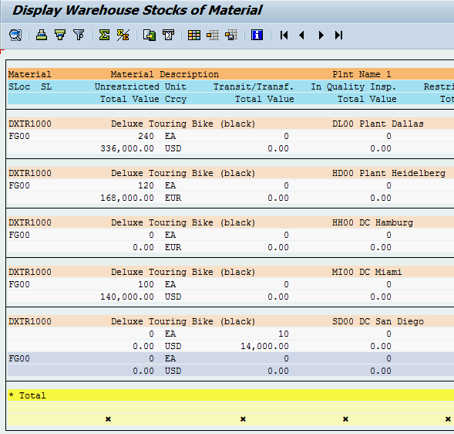
As you can see the values associated with the material in Dallas has decreased. Also the value of Transit/Transf. for San Diego has now increased to the value of the goods on order.
Click on the exit icon twice to return to the SAP Easy Access screen.

 | Step 8: Create Goods Receipt
Task Receive goods at receiving plant. Time 5 min
Short Description Use the Easy Access Menu to confirm the receipt of goods from Dallas by creating a goods receipt.
Name (Position) Yoshi Agawa (Receiving Clerk)
To create a goods receipt, follow the menu path:  Logistics ► Materials Management ► Inventory Management ► Goods Movement ► Goods Movement |  | Menu path
In the Goods Movement screen, change the Material Document drop down to Goods Receipt, adjust the type of Goods Receipt to a Purchase Order, and input your Stock Transport Order Number in the blank space next to it. You may use the F4 help like explained in the goods issue task. Then, click on or press Enter. |  | Goods Receipt  Purchase Order  Stock Transport  Order Number
After your stock transport order comes up select OK. Make sure that SD00 is chosen as Plant, 101 as Movement Type and FG00 as Storage Location (for some of this information you may need to scroll over to the right to find it). |  | OK  SD00  101  FG00
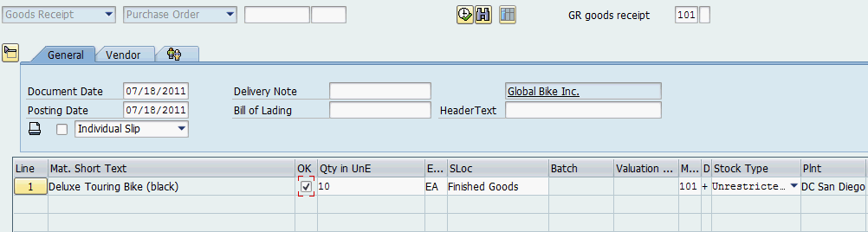
Then, click on to save your receipt. The system will assign a unique material document number. |  | Material Document Number
Click on the exit icon to return to the SAP Easy Access screen.

 | Step 9: Display Material Inventory
Task View the inventory of your material again. Time 5 min
Short Description Use the Easy Access Menu to display the inventory of your material again.
Name (Position) Carolin Bruzik (Warehouse Supervisor)
To display the material inventory, follow the menu path:  Logistics ► Materials Management ► Inventory Management ► Environment ► Stock ► Stock Overview |  | Menu path
In the Stock Overview screen, enter DXTR1### as Material (remember to replace ### with your number). Ensure that all other search criteria fields are blank and click on . |  | DXTR1###
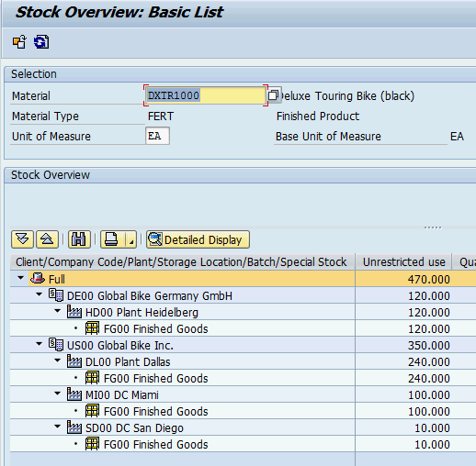
Note that your amount of goods in San Diego has changed now. By double clicking on SD00 DC San Diego you can see that the On-Order Stock balance is now zero for San Diego and its Unrestricted Use has been updated.
Click on the exit icon to return to the SAP Easy Access screen.

 | Step 10: Display Material Inventory Value
Task View the value of your material inventory again. Time 5 min
Short Description Use the Easy Access Menu to display the value of your material inventory again.
Name (Position) Carolin Bruzik (Warehouse Supervisor)
To display the material inventory value, follow the menu path:  Logistics ► Materials Management ► Inventory Management ► Environment ► Stock ► Warehouse Stock |  | Menu path
In the Display Warehouse Stocks of Material screen, enter DXTR1### as Material (remember to replace ### with your number). Ensure that all other search criteria fields are blank and click on . |  | DXTR1###
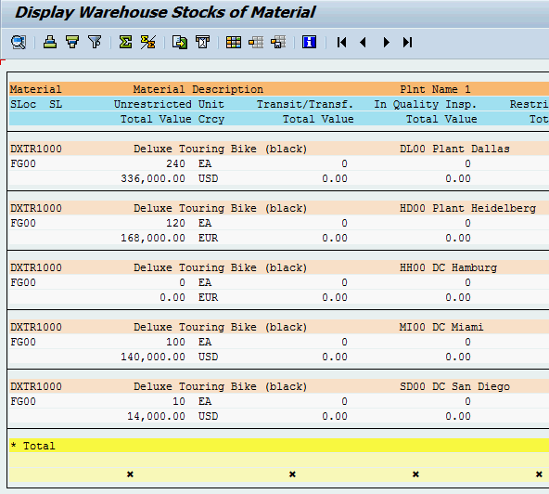
As you can see the value of Transit/Transf. for San Diego is now zero and its Unrestricted Amount and Total Value increased.
Click on the exit icon twice to return to the SAP Easy Access screen.

 | Step 11: Run Bin Status Report
Task Check the status of your bins. Time 5 min
Short Description Use the Easy Access Menu to run a bin status report which will display a detailed report of each storage bin within the specified warehouse.
Name (Position) Carolin Bruzik (Warehouse Supervisor)
To run a bin status report, follow the menu path:  Logistics ► Logistics Execution ► Internal Whse Processes ► Bins and Stock ► Display ► Bin Status Report |  | Menu path
In the Bin Status Report: Initial Screen, enter 100 (for your San Diego Warehouse) as Warehouse Number and STBN*### as Storage bin (replace ### with your number). Then, click on . |  | 100  STBN*###
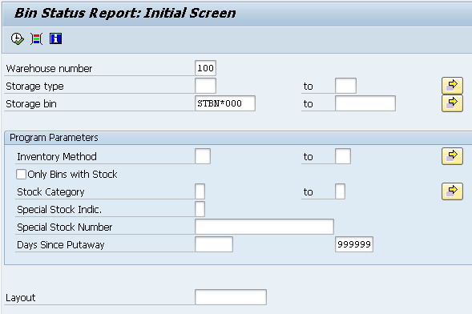
In the Bin Status Report: Overview screen you should see a list of all of your storage bins for the entire warehouse in San Diego. Double click on one of your storage bins to get detailed information.
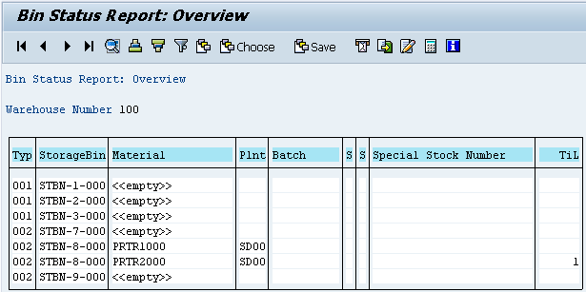
Note: Your bin report might look different dependent on whether or not you have already processed a Warehouse Management case study.
Click on the exit icon twice to return to the SAP Easy Access screen.

 | Step 12: Create Transfer Order
Task Create a transfer order. Time 10 min
Short Description Use the Easy Access Menu to create a transfer order to place your goods into your storage bin. It is a handoff from inventory management to warehouse management. The system recognizes that there are goods that have been received, but need to be put away.
Name (Position) Yoshi Agawa (Receiving Clerk)
To create a transfer order, follow the menu path:  Logistics ► Logistics Execution ► Inbound Process ► Goods Receipt for Purchase Order, Order, Other Transactions ► Putaway ► Create Transfer Order ► For Material |  | Menu path
In the Display Transfer Requirement: List of Material screen, enter 100 (for your San Diego Warehouse) as Warehouse Number, DXTR1### as Material (replace ### with your number) and SD00 as Plant. Then, click on or press Enter. |  | 100  DXTR1###  SD00
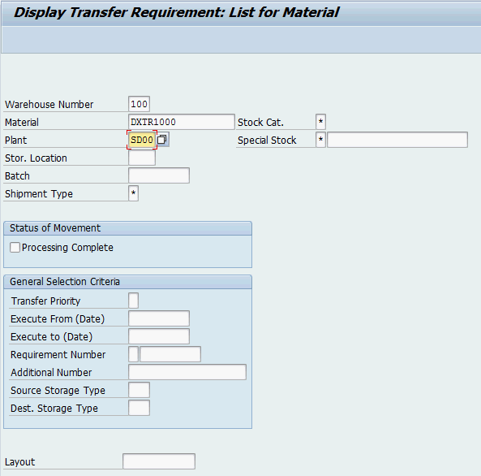
In the Transfer Requirements for Material screen, you should see a line item describing the goods just received for your stock transport order. The requirement number should be the same as the stock transport order number you received earlier. Make sure that the line item is selected and click on the button.
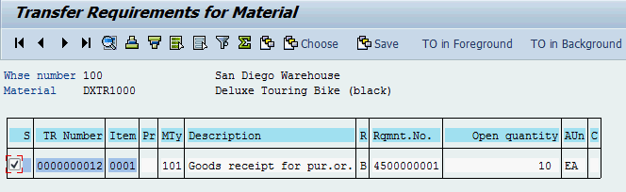
In the Create TO for TR 00000000XX 0001: Prepare for Putaway screen, hit or press Enter to copy your quantity of 10 from the Palletization section to the Items section. Enter 001 as Sec, STBN-7-### as Destination Bin (replace ### with your number) and use F4 to select Pallet Storage as Type. Confirm your entries by clicking or pressing Enter. |  | 001  STBN-7-###  002 (Pallet Storage)
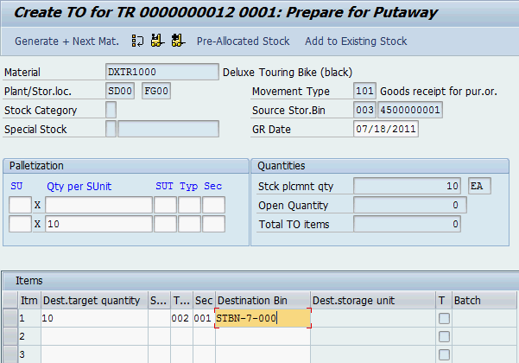
Then, click on to save your transfer order. The system will assign a unique transfer order number.  Please write down this number. |  | Transfer Order Number
Click on the exit icon twice to return to the SAP Easy Access screen.

 | Step 13: Confirm Transfer Order
Task Confirm your transfer order. Time 5 min
Short Description Use the Easy Access Menu to confirm the transfer order you created in the previous step. This is confirming that the goods are physically in the storage bin indicated in the transfer order.
Name (Position) Yoshi Agawa (Receiving Clerk)
To confirm a transfer order, follow the menu path:  Logistics ► Logistics Execution ► Inbound Process ► Goods Receipt for Purchase Order, Order, Other Transactions ► Putaway ► Confirm Transfer Order ► Single Document ► In One Step |  | Menu path
In the Confirm Transfer Order: Initial Screen, enter the TO Number from the previous task and 100 as Warehouse Number. Then, click on or press Enter. |  | TO Number  100
Note: If you have not written down the number you can search for it using the transaction code LT23.
In the Transfer Orders: List of Resident Documents you have to fill in 100 as Warehouse number. Then, click on .
In the Confirm Transfer Order: Overview of Transfer Order Items screen, you should see an overview of your transfer order created in the previous step. Review all of the details to make sure you have the correct quantity and storage bin.
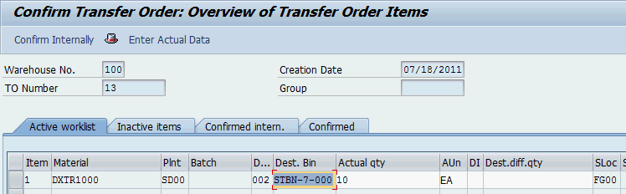
Then, click on to confirm your transfer order. The system will return a success message.
Click on the exit icon twice to return to the SAP Easy Access screen.

 | Step 14: Run Bin Status Report
Task Check the status of your bins again. Time 5 min
Short Description Use the Easy Access Menu to run a bin status report, which will display a detailed report of each storage bin within the specified warehouse.
Name (Position) Carolin Bruzik (Warehouse Supervisor)
To run a bin status report, follow the menu path:  Logistics ► Logistics Execution ► Internal Whse Processes ► Bins and Stock ► Display ► Bin Status Report |  | Menu path
In the Bin Status Report: Initial Screen, enter 100 (for your San Diego Warehouse) as Warehouse Number and STBN*### as Storage bin (replace ### with your number). Then, click on . |  | 100  STBN*###
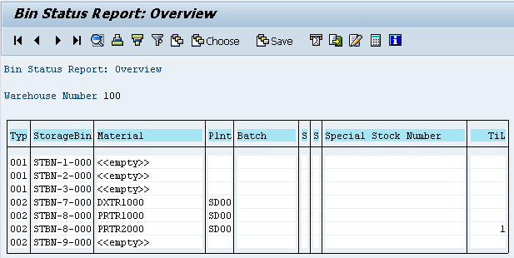
In the Bin Status Report: Overview screen you should see that the StorageBin STBN-7-### is filled now. Click on your material to display detailed information of this quant and check whether 10 pieces of your good are stored in your storage bin.
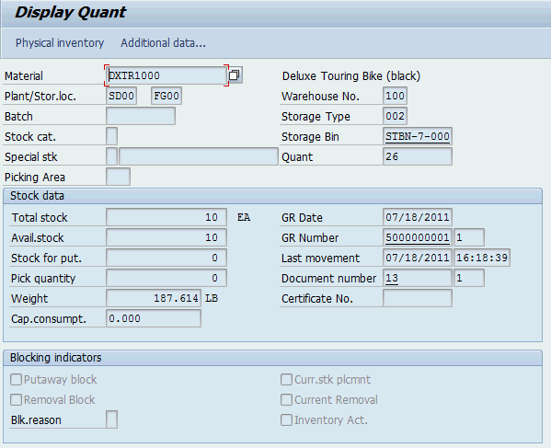
Click on the exit icon to return to the SAP Easy Access screen.

WM II Challenge
Learning Objective Understand and perform a warehousing process for int. goods Time 80 min
Motivation After having finished the Warehouse Management II case study successfully you should now be able to solve the following challenge.
Scenario The warehouse management system has been tested without any problems, so the management decided to use the system productively. The distribution center in San Diego will be delivering customers very soon. In order to do so you need to ensure that there are enough black Deluxe Touring Bikes available on stock. Unfortunately, you cannot order any from your plant in Dallas, because due to problems with one of the assembly lines there are no free resources available. In order to have 50 black Deluxe Touring Bikes (estimation by the management) in San Diego on time you need to order them from your plant in Heidelberg (Germany). The delivery time is 10 days maximum.
As soon as the goods arrive in your DC in San Diego they need to be stored in the same bin where the black Touring Bikes from this case study already are.
Task Information You can use the Warehouse Management II case study as a guideline but it is recommended to complete this challenge without further assistance to prove your WM skills.

